# RCC_Settings

All shared settings can be found at **Tools 🡪 BoneCracker Games 🡪 Realistic Car Controller 🡪 Edit Settings**. **(Shift + S)**. All RCC vehicles will take an instance of these settings and use them. These settings are global shared settings.

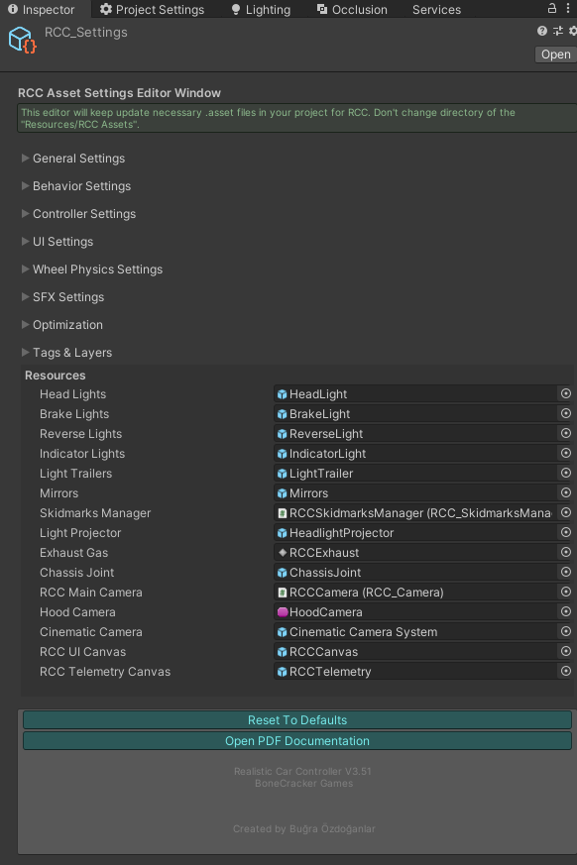

To access the instance, you can use **RCC_Settings.Instance**; For example;

*RCC_Settings.Instance.mobileControllerEnabled = true;*

All categories have been explained below…

# General Settings

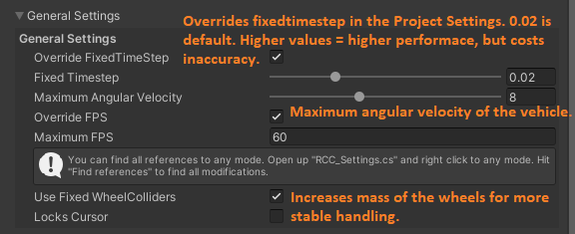

*Override FixedTimeStep*: Overrides fixedtimestep in the Project Settings (Physics tab). 0.02 is default. On lower values, FixedUpdate() method will run much often, but costs performance. On higher values, method will run less frequently. Performance will increase, but costs inaccuracy of physics.

*Override FPS*: Sets Application.targetFrameRate to a fixed value.

*Use Fixed WheelColliders*: Increases mass of the wheels for more stable handling.

*Locks Cursor*: Locks cursor when the game starts. Can be unlocked with escape / back buttons.

# Behavior Settings

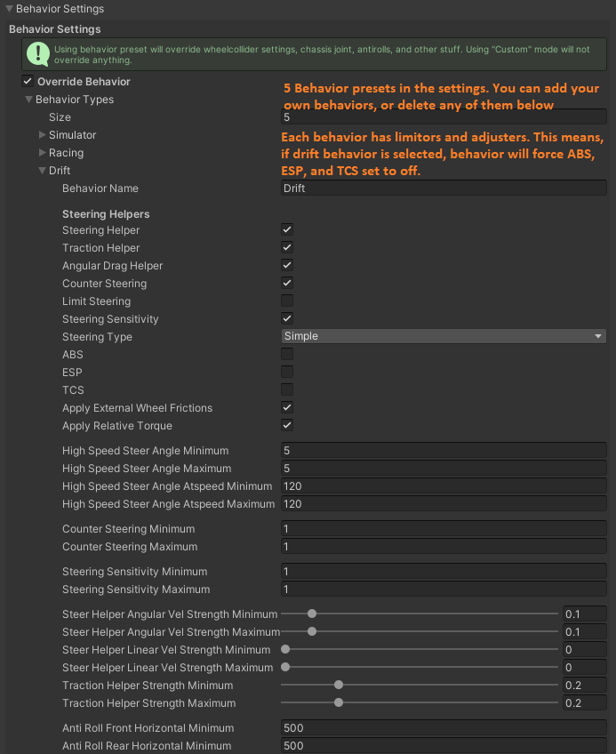

All behaviors in the demo are stored here. You can use, edit, remove any of them. Also you can add your own behavior too. Behaviors are simply checks settings of the car controller and limits some variables and set on / off stability systems. For example, in drift mode, all stability systems are set to off. And counter steering is limited to 1. You can select any behavior in your code by

**RCC.SetBehavior(int index);**

# Controller Settings

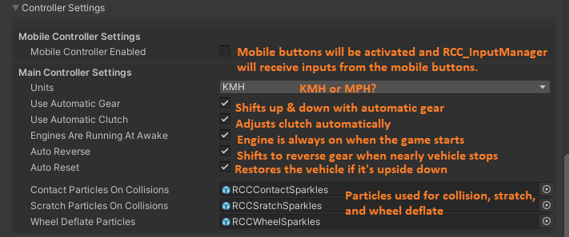

You can set mobile controller type by **RCC.SetMobileController(RCC_Settings.MobileController mobileController);**

# SFX Settings

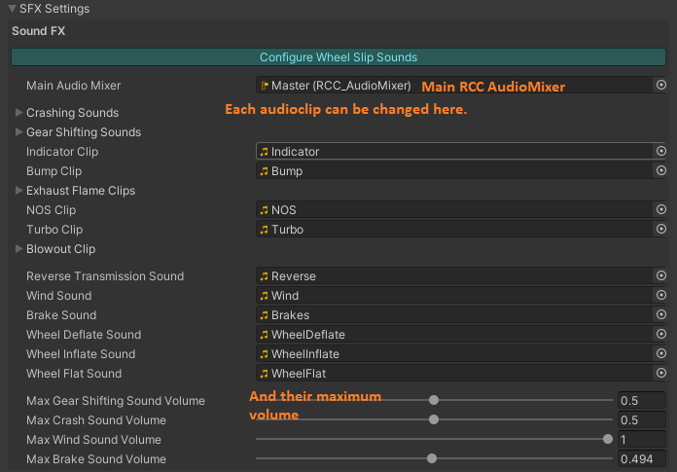

# Optimization

# 

For mobile platform, you can enable “Use Lights As Vertex Lights”. This means, lights are not effective, and they will work on “Not Important” mode for avoid performance issues. For realistic lighting, you can disable this option. This option overrides cullingMask and renderMode of the light in RCC_Light.cs script.

# Tags & Layers

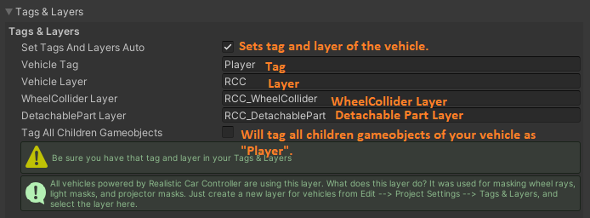

Layers are used for unwanted collisions and raycast hits. For example, we don’t want to collide wheelcollider with detachable part. Otherwise some weird things will happen.

# Resources

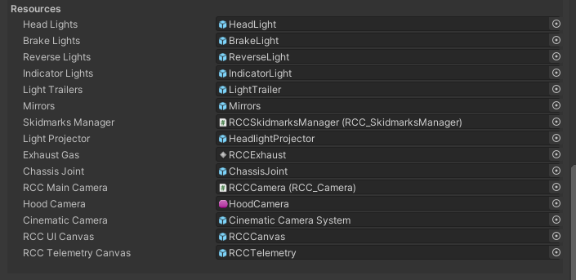

RCC will use these assets for the base structure. I wouldn’t recommend you to change them unless you know what you are doing.